Input paper: [1] VTS56-8.1.2

Input paper for the following Committee(s): check as appropriate Purpose of paper:

**□** ARM **□** ENG **□** PAP **X** Input

**□** ENAV **X** VTS **□** Information

Agenda item [2] 8.1

Technical Domain / Task Number 2 1.1.3

Author(s) / Submitter(s) China Maritime Safety Administration

Functional requirements for VTS systems under the influence of MASS

# Summary

China MSA summarized the management and service experience of VTS on the smart vessel “ZHIFEI”, proposed the functional requirements of VTS system under the influence of MASS and the management and service rules of VTS on the sea trial of MASS.

## Purpose of the document

This document aims to share the China MSA's experience in MASS management to provide input document for the VTS committee to promote the task 1.1.3.

## Related documents

VTS 51: Possible-case-studies-Operations-and-Trials-of-Autonomous-Ships-24-Jan-22.

VTS53-12.1.2-New VTS Task Register 2023-2027.

VTS55-13.1 Report of VTS55.

# Background

The test and operational cases published by IALA on MASS lack details of smart facilities and fail to cover the proposed interaction of MASS with VTS.

ZHIFEI (LOA 117, design speed 12 knots, capacity 316 TEU) is the only intelligent container vessel in China that has successfully demonstrated remote piloting and autonomous navigation in commercial operation. Since it has been put into commercial operation, ZHIFEI has sailed more than 26,000 nautical miles and navigated in the VTS area for more than 500 times. These data not only verified the reliability of its technology, but also provided a valuable practical basis for future coordination between MASS and VTS.

# Discussion

## ZHIFEI's smart system

The vessel of ‘ZHIFEI’ has three navigation modes: Navigation Assistance mode, remote control mode and autonomous navigation mode. It can realize the functions of independent route planning, intelligent collision avoidance, automatic berthing and remote control navigation.

### Navigation assistance system

Based on data fusion for three-dimensional situational reconstruction, the system integrates COLREGS and good seamanship to provide intelligent navigation advice. It can offer the following services:

* intelligent navigation and route planning;
* navigation and collision avoidance suggestions;
* three-dimensional reconstruction of the surrounding environment;
* real-time multi-dimensional monitoring of the engine room environment and status.

### Autonomous navigation system

The system integrates the functions of automatic berthing, autonomous collision avoidance, and autonomous tracking, supports the reconfiguration of the environment around the vessel to enable autonomous navigation.

### Remote control system

This system is a remote control system based on multi-dimensional information perception. It integrates real-time supervision, remote control and collision warning functions. It mainly realises the following functions and services:

* real-time return of navigation status information;
* real-time return and reconstruction of environmental multi-dimensional perception information;
* remote monitoring of the status of the whole vessel's equipment;
* early warning and monitoring of accidents.

### Intelligent ENC

The system is an intelligent electronic nautical chart based on big data and AI algorithms, integrating multi-dimensional perception, meteorological early warning and intelligent navigation, which is a comprehensive upgrade of traditional nautical charts, with the functions of customised editing of object labels and integrated display of multi-dimensional information.

### Visual enhancement system

The visual enhancement system, based on AR and VR data fusion, provides distortion-free display of the surrounding environment of ZHIFEI. It is a marine intelligent visual assistance system that integrates active blind spot assistance for berthing, AR, and VR reconstruction functions. It support customization service, 360° panoramic image; active blind spot assisted berthing warning; AR+3D virtual reality reconstruction.

### Communication

The main communication modes adopted by ZHIFEI are satellite and shore-based communication networks (4/5G). Satellite communication can cover the entire route of ZHIFEI. Due to the limitation of satellite delay, the minimum delay is 600ms, the average delay of service is about 900ms, and the maximum uplink and downlink bandwidth of the current service is 5 Mbps uplink and 10 Mbps downlink, which can guarantee 3 channel video and service data demand when there is no electromagnetic interference or antenna blockage during the voyage.

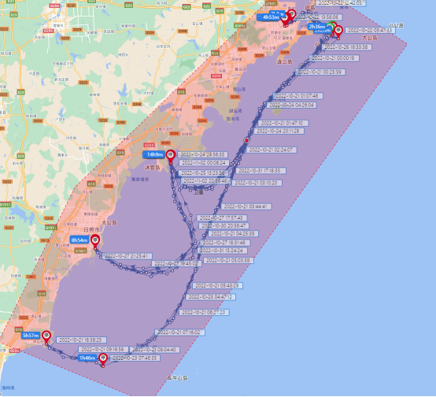

1. routes under satellite network coverage

4G signal is greatly affected by the density and height of shore base station, when the base station location is ideal, 4G signal coverage can reach 5-10 nautical miles, and the average delay is less than 200ms. The main disadvantage is that during the ship's voyage, it has to pass through multiple base stations, and the process of switching signals from base station to base station will cause the network to reconnect, which takes about 3-5 seconds.

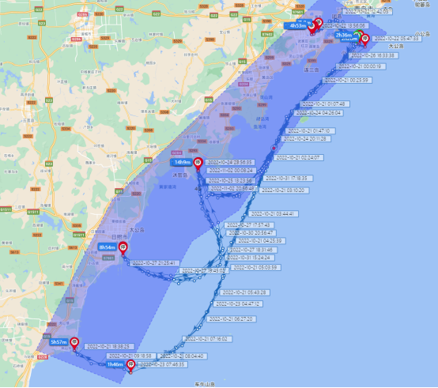

1. routes under 4G network coverage

With the increase in the number of 5G base stations, the 5G signal along the coast has been improved, but the coverage area is around 4-5 nautical miles offshore, with the same problems of base station switching and signal along with switching.

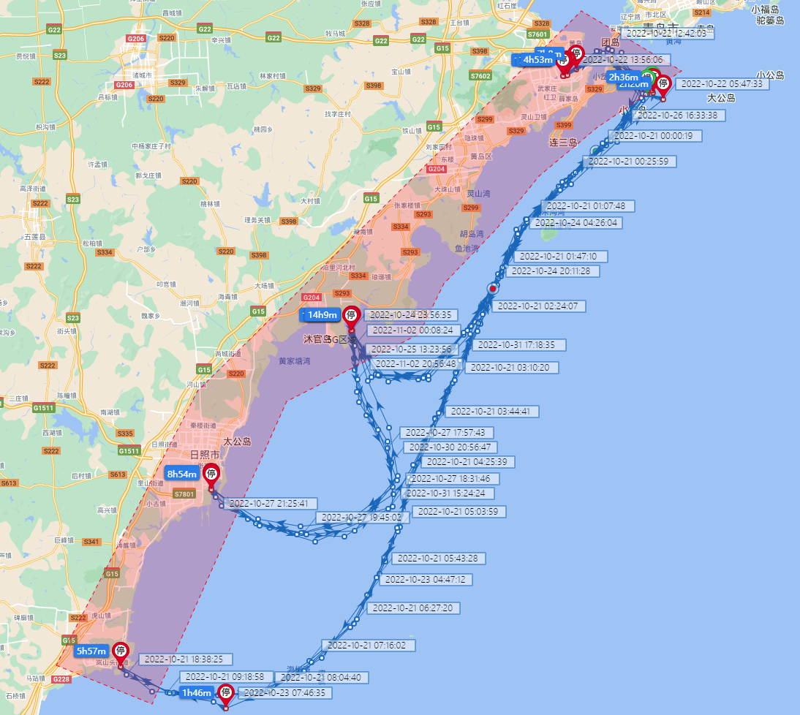

1. routes under5G network coverage

## VTS management and services for ZHIFEI

### Management

ZHIFEI shall provide the following information to VTS prior to the commencement of the voyage:

* sailing plan；
* emergency plan with emergency contact details;
* Crew list;
* Hydrological and meteorological conditions during navigation period;

VTS reviews the above information.

### services

VTS issues the sailing plan of ZHIFEI to alert other vessels. If necessary, VTS issues navigational warning.

During the navigation in the VTS area, VTS monitors the movements of ZHIFEI and timely provides information services and other related services.

## Functional requirements of the VTS system

ZHIFEI navigates through the VTS area of Qingdao VTS and Rizhao VTS. Compared with the information interaction between Zhi Fei and the shore-based remote control centre, the information interaction between VTS and ZHIFEI still relies on traditional means of communication, such as VHF, due to the lack of upgraded functions of the VTS system for MASS. After comparison, the VTS system should have the following new functions:

1. Enhanced monitoring capability

The VTS system needs to be able to identify and monitor the position and movement of MASS in real time, especially in congested waterways or under complex meteorological conditions. Considering that MASS has the autonomous collision avoidance function, the VTS system should have the capability to share and validate collision avoidance information with its system for more efficient traffic organization and risk management.

1. Better communication capability

The VTS system should have more powerful communication capability in order to obtain the navigation data, equipment status data, and environmental data of MASS in real time, and to meet the needs of advanced assisted navigation and remote control of MASS.

1. Higher data processing and analysis capability

The VTS system should have the ability to analyse and process data from different data sources in order to provide more accurate navigational aids and decision-making support, especially through the analysis and processing of the planned routes and real-time navigational data of the MASS to prejudge the routes' intersection areas and give solutions to reduce the risk of collision.

1. Stronger cyber security system

VTS should establish a high standard of cyber security protection system to protect data from external attacks.

# Action requested of the Committee

The Committee is requested to consider the proposals provided in this document and take actions as appropriate.

# Annex

1. The Sea Trial Management System of MASS

ANNEX A THE SEA TRIAL MANAGEMENT SYSTEM OF MASS

The emergence of MASS is a remarkable achievement of scientific and technological progress in the field of shipping. However, the existing relations of production are difficult to fully meet the actual needs of MASS development. In order to promote the healthy development of MASS, China MSA has formulated the relevant management system.

1. the Organization

A management group has been set up for the sea trial of MASS, which is responsible for organizing and coordinating all the work of the sea trial of MASS. There are four working groups under the management group, namely:

* Navigation Safety and Monitoring Working Group

Responsible for guiding the safety work of ship navigation.

* Ship Survey and Management Working Group

Responsible for guiding ships to apply for the "Autonomous Navigation and Remote Control Navigation Survey Report" from ship survey agencies and conducting safety inspections on ships and remote control stations before navigation.

* Watchkeeping and Ship Manning Working Group

Responsible for guiding the ship manning during navigation.

* Communication and Cyber Security Working Group

Responsible for guiding the communication and network security assessment of ship navigation.

1. sea trial Requirements
   1. Sea trial subject

The sea trial subject, namely the responsible unit of the vessel, should be a legitimate shipping company, an administrative authority, or an owner of yachts of 24 meters or above. If a shipping company is required to establish a safety and pollution prevention management system according to regulations, it should obtain a company "Document of Compliance" issued by the maritime administration.

The sea trial subject, before the sea trial of the vessel, should complete the risk assessment of the ship and the remote control station, develop a navigation programme based on the risk assessment.

The sea trial subject should establish a contingency plan and carry out drills to keep the navigation risk at the lowest level. If a maritime traffic accident or distress occurs during the sea trial, the navigation should be immediately suspended, contingency response procedures should be activated, and the nearest maritime administration should be reported to in a timely manner.

The sea trial subject shall ensure that the vessel and related systems, equipment, and networks comply with national safety and technical requirements, and data storage meets national requirements.

* 1. Sea trial vessel

The sea trial vessel shall hold valid ship registration certificate and ship survey certificate in accordance with the law. If necessary, a valid ship Safety Management Certificate shall be held.

Vessels should pass a safety inspection by the Maritime Administration one month prior to their first voyage.

Systems and equipment concerning ship autonomous navigation and remote control functions should be accompanied by marine product certificates or relevant certificates of the design and manufacturing departments.

* 1. Sea trial personnel

All crew members, person in charge of navigation, remote control station operators, and other personnel involved in navigation on the vessel are collectively referred to as navigation personnel.

Vessels must be manned with qualified, healthy and competent crew members in accordance with the requirements of the Minimum Safety Manning Certificate.

The number of navigation personnel (including crew members) on board the vessel shall not exceed the capacity of the vessel's life-saving equipment.

* 1. Sea trial area

The sea trial area must be approved by the competent authority, and a navigation warning must be issued by the competent authority during the trial period.

In principle, the sea trial area should be far away from fairways, anchorages and other heavily trafficked waters. If it is necessary to navigate in the fairway, a safeguard programme should be formulated and targeted navigation safety measures should be taken.

VTS shall provide service for the sea trial of MASS, and implement measures such as traffic control if necessary.

When the navigation is completed, relevant navigation facilities and equipment should be promptly cleaned, and no obstructions should be left.

1. Sea trial management
   1. Report

The sea trial subject shall report the following information to the competent authority before the start of the trial:

* Outline of the ship's remote control and autonomous navigation, risk assessment reports, contingency plans, etc;
* List of personnel involved in the trial voyage;
* Range of navigational waters;
* Application for issuing navigational warnings;
* Hydro-meteorological conditions during navigation;
* Other documents that need to be provided.
  1. Verification

After receiving the ship's navigation report, VTS shall organize a review of the completeness of the documents provided by the responsible unit of the ship.

The competent authority shall examine the completeness of the documents provided by the sea trial subject.

The competent authority shall carry out the safety inspection and on-site supervision of the sea trial vessel in accordance with the relevant ship technical regulations and procedures, including:

* Checking the qualifications and curriculum vitae of the crew, the sea trial commanders and other relevant personnel;
* Checking the familiarity of the sea trial personnel with the vessel, the sea trial area and the emergency plan, and organizing emergency drills if necessary;
* Check the control conversion mechanism between the ship's remote control station and the bridge, focusing on the control rights of the vessel acquired by the crew in case of emergency;
* Check the communication and navigation system between ship and shore, focusing on the communication between the vessel and the remote control station, the vessel and the VTS centre, and the remote control station and the VTS centre.

1. trial Report

Within 5 working days after the end of the sea trial, the sea trial subject shall report to the competent authority on the circumstances of the sea trial and the relevant navigational data (except for those involving commercial secrets).

1. Input document number, to be assigned by the Committee Secretary
2. Leave open if uncertain